- Explain the architecture of Docker
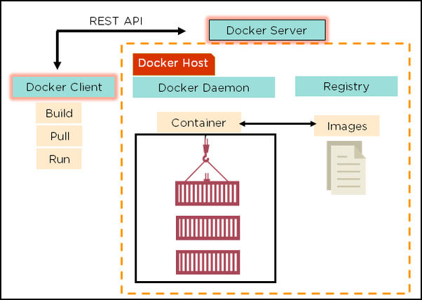
- Docker uses a client-server architecture
- Docker Client is a service which runs a command. The command is translated using REST API and is sent to the Docker Daemon (server)
- Docker Daemon accepts the request and interacts with the operating system in order to build Docker Images and run Docker containers
- A Docker Image is a template of instruction which is used to create containers
2. What are the advantages of Docker over Virtual machines
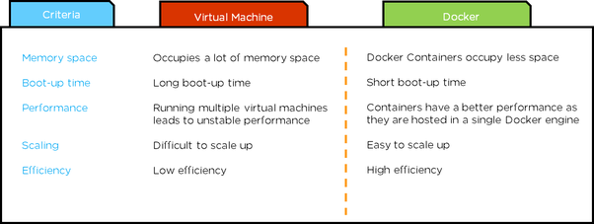
3. How do we share Docker containers with different nodes?
- It is possible to share Docker containers on different nodes by using Docker swarm
- Docker swarm is a tool which allows IT administrators and developers to create and manage a cluster of swarm nodes within the Docker platform
- A swarm consists of two types of nodes: manager node and worker node
4. What are the commands to create a Docker swarm?
Create a swarm where you want to run your manager node
Docker swarm init --advertise-addr <MANAGER-IP>
Once you’ve created a swarm on your manager node, you can add worker nodes to your swarm
When a node is initialized as a manager node, it immediately creates a token. In order to create a worker node the following command (token) should be executed on the host machine of a worker node
Docker swarm join \ --token SWMTKN-1-49nj1cmql0jkz5s954yi3oex3nedyz0fb0xx14ie39trti4wxv-8vxv8rssmk743ojnwacrr2e7c \ 192.168.99.100:2377
5. How to run multiple containers using a single service?
- It is possible to run multiple containers as a single service by using Docker compose
- Here, each container runs in isolation but can interact with each other
- All Docker Compose files are YAML files
6. What is the use of a Dockerfile?
- In Docker, Docker File is used for creating Docker Images using the build command
- With Docker Image, any user can run the code in order to create Docker Containers
- Once a Docker Image is built, it’s uploaded in a Docker registry
- From the Docker Registry, users can get the Docker Image and build new containers whenever they want
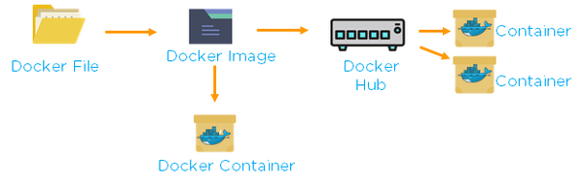
7. Differences between Docker Image and Docker Container
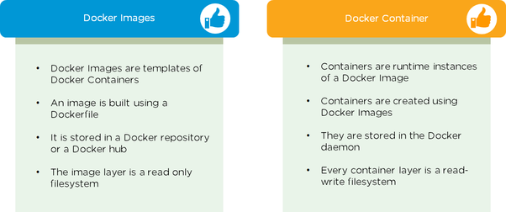
8. Instead of YAML what can be an alternate file to build Docker compose
To build a Docker compose, a user can use a JSON file instead of YAML
In case a user wants to use a JSON file, he/she should specify the filename as given:

9. How to create a Docker container?
Task: Create a MySQL Docker container
- A user can either build a Docker Image or pull an existing Docker Image (like MySQL) from Docker hub
- Now, Docker creates a new container MySQL from the existing Docker Image. Simultaneously, container layer of a read-write filesystem is also created on top of the Image layer
- Command to create a Docker container: Docker run -t –i MySQL
- Command to list down the running containers: Docker ps
10. What are the Cloud platforms that support Docker?
Below are the Cloud platforms that Docker runs on:
- Amazon Web Services
- Microsoft Azure
- Google Cloud Platform
- Rackspace
11.What is Docker hub?
Docker hub is a cloud-based registry service which allows you to link to code repositories, build your images and test them, stores manually pushed images, and links to Docker cloud so you can deploy images to your hosts. It provides a centralized resource for container image discovery, distribution and change management, user and team collaboration, and workflow automation throughout the development pipeline.

